**Business Recommendation Report**

**1. Best Time for Investment**

Analysis shows that **Quarter 4** (October to December) consistently delivers the **highest profits** each year. Therefore, any future investment—whether in staffing, marketing, or inventory—should be prioritized during this period to maximize returns.

**2. Cost Management During Low-Profit Periods**

In contrast, **Quarter 1** (January to March) has shown the **lowest profitability**. To optimize costs, businesses should consider **reducing expenses** during this time. This may include limiting temporary hires, optimizing stock levels, or pausing non-essential expenditure.

Figure 1: Quater4 vs Quater 1

**3. Focus on High-Performing Cities**

The cities of **New York City, Los Angeles, Seattle, San Francisco**, and **Philadelphia** are consistently the **most profitable and active in terms of order volume**. Strengthening operations in these regions—through increased marketing, better shipping services, or improved stock availability—can lead to stronger sales growth.

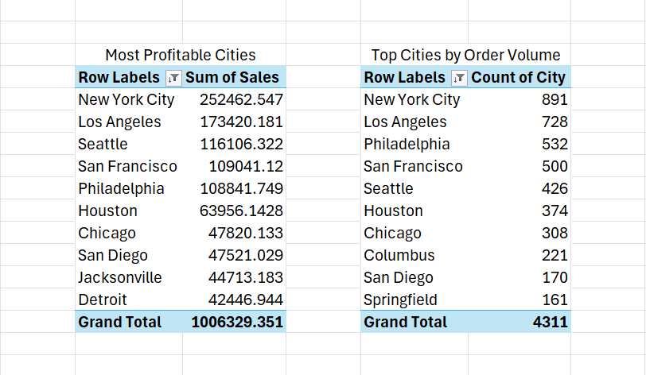

Figure 2: Top cities in terms of most sales and order volume

**4. Align Stock with Customer Preferences**

High-value customers tend to buy from the following product categories:

* Binders
* Chairs
* Copiers
* Supplies
* Machines
* Phones
* Art

These are also among the **top-selling categories overall**. Ensuring these items are always well-stocked will help meet demand and drive revenue.

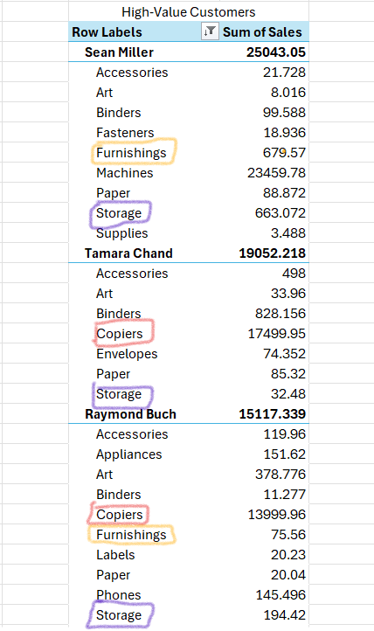

Figure 3: Popular Sub-Categories Among Key Customers

**5. Embrace Product Variety**

Within each category, multiple products contribute to high sales—not just one or two bestsellers. This suggests that **diverse product offerings** are more effective than relying on a limited range. Businesses should maintain a **broad selection**, especially within high-performing sub-categories, to appeal to a wider range of customers.

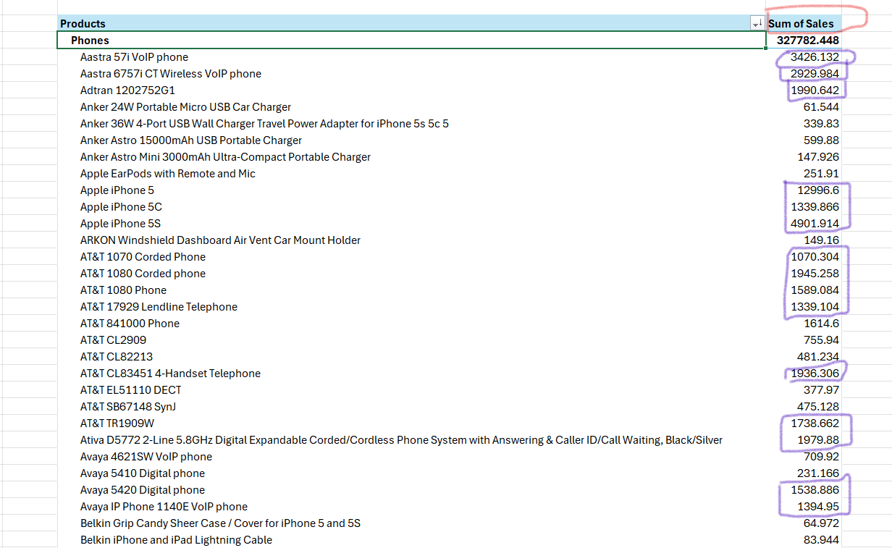

Figure 4: Phone Sub-Category as an example